

C219 Front-end Web Development

# **Lesson 9**

### Data Interaction and Visualisation using JavaScript

START



**Recap**

Last lesson, we learned about the Anime.js and fullPage.js libraries to create an interactive single page website. Visit the websites below to recap on the topics covered.

[Anime.js](https://animejs.com/)

* Anime.js is a JavaScript animation library with a simple, yet powerful API. It works with CSS properties, SVG, DOM attributes and JavaScript Objects.

[fullPage.js](https://alvarotrigo.com/fullPage/)

* fullPage.js is a JavaScript library that creates fullscreen scrolling websites, also known as single page websites.



**Data Interaction and Visualisation**

Today, we will learn how to leverage on JavaScript libraries to create a web page that presents data with interaction and visualisation.

Data interaction provides mechanisms for people to interact explicitly with systems and data.

Data visualization is the graphical representation of information using charts, graphs and maps.



**JavaScript Libraries**

The three JavaScript libraries you will learn today are:



[Chart.js](https://www.chartjs.org/) [Tippy.js](https://atomiks.github.io/tippyjs/) [DataTables](https://datatables.net/)



**DataTables**



[DataTables](https://datatables.net/)



**DataTables**

Activity 1

Visit [https://datatables.net](https://datatables.net/) to try out the interactive features in this table.

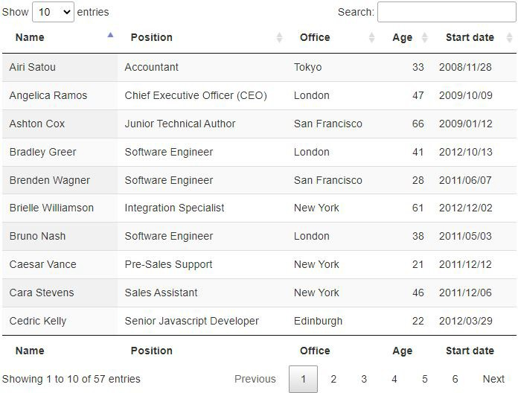DataTables is a plug-in for the jQuery Javascript library. It is a highly flexible tool, built upon the foundations of progressive enhancement, that adds advanced features to any HTML table.

It offers features like pagination, instant search, multi-column ordering, responsiveness, and more.



DataTables

**Getting Started**

First of all, include the files for DataTables. DataTables has one library dependency – jQuery. Hence, you need to include the CDN links for both jQuery and DataTables.

jQuery:

<script src="https://cdnjs.cloudflare.com/ajax/libs/jquery/3.6.0/jquery.min.js"></script>

DataTables:

<link rel="stylesheet" type="text/css" href="https://cdn.datatables.net/1.11.3/css/jquery.dataTables.min.css">

**CSS**

<script src="https://cdn.datatables.net/1.11.3/js/jquery.dataTables.js"></script>

**JS**



DataTables

**Usage** – HTML Table

Activity 2

Use exercise1.html in your Resources folder and try this yourself. Add more data to view the pagination in action.

For DataTables to be able to enhance an HTML table, the table must include valid, well formatted HTML, with a table header <thead> and a table body <tbody>.

HTML: JavaScript:

$(document).ready(function() {

$('#example').DataTable();

});

To initialize DataTables to a HTML table, target it’s ID or class and run the DataTable() function on it.

<table id="example" class="display">

<thead>

<tr><th>Column 1</th><th>Column 2</th></tr>

</thead>

<tbody>

<tr><td>Row 1 Data 1</td><td>Row 1 Data 2</td></tr>

<tr><td>Row 2 Data 1</td><td>Row 2 Data 2</td></tr>

</tbody>

</table>



DataTables

**Usage** – JavaScript Arrays

Activity 3

Use exercise2.html in your Resources folder and try this yourself. Copy the data source from L09 Notes.docx.



You can also use JavaScript arrays as the data source for a DataTable. Each item in that array will define a row to be displayed. Note that you need to specify the column names in the options. Each item in the array will be mapped to the corresponding column in order.

Data source: Initialisation:

var dataSet = [

["Tiger Nixon", "System Architect", "Edinburgh", "5421", "2011/04/25", "$320,800"], ["Garrett Winters", "Accountant", "Tokyo", "8422", "2011/07/25", "$170,750"],

["Ashton Cox", "Junior Technical Author", "San Francisco", "1562", "2009/01/12", "$86,000"], ["Cedric Kelly", "Senior Javascript Developer", "Edinburgh", "6224", "2012/03/29",

"$433,060"],

["Airi Satou", "Accountant", "Tokyo", "5407", "2008/11/28", "$162,700"],

["Brielle Williamson", "Integration Specialist", "New York", "4804", "2012/12/02", "$372,000"],

["Herrod Chandler", "Sales Assistant", "San Francisco", "9608", "2012/08/06", "$137,500"], ["Rhona Davidson", "Integration Specialist", "Tokyo", "6200", "2010/10/14", "$327,900"], ["Colleen Hurst", "Javascript Developer", "San Francisco", "2360", "2009/09/15",

"$205,500"],

["Sonya Frost", "Software Engineer", "Edinburgh", "1667", "2008/12/13", "$103,600"], ["Jena Gaines", "Office Manager", "London", "3814", "2008/12/19", "$90,560"], ["Quinn Flynn", "Support Lead", "Edinburgh", "9497", "2013/03/03", "$342,000"]

];

$(document).ready(function () {

$('#example').DataTable({ data: dataSet, columns: [

{ title: "Name" },

{ title: "Position" },

{ title: "Office" },

{ title: "Extn." },

{ title: "Start date" },

{ title: "Salary" }

]

});

});



DataTables

**Documentation**

View the [documentation](https://datatables.net/manual/) for DataTables to learn more about it.

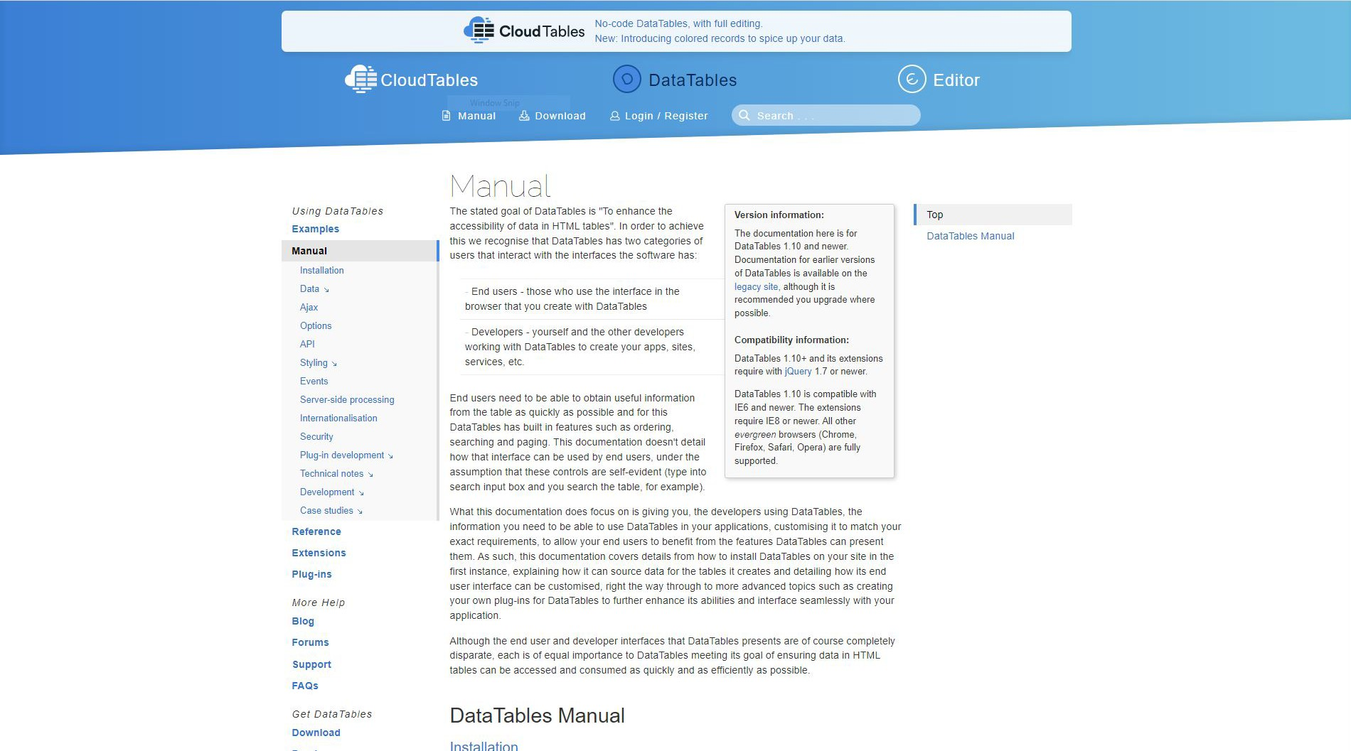



**Chart.js**



[Chart.js](https://www.chartjs.org/)



**Chart.js**

Activity 4

Visit the [Samples](https://www.chartjs.org/docs/latest/samples/bar/vertical.html) page to try out all the amazing features of Chart.js.

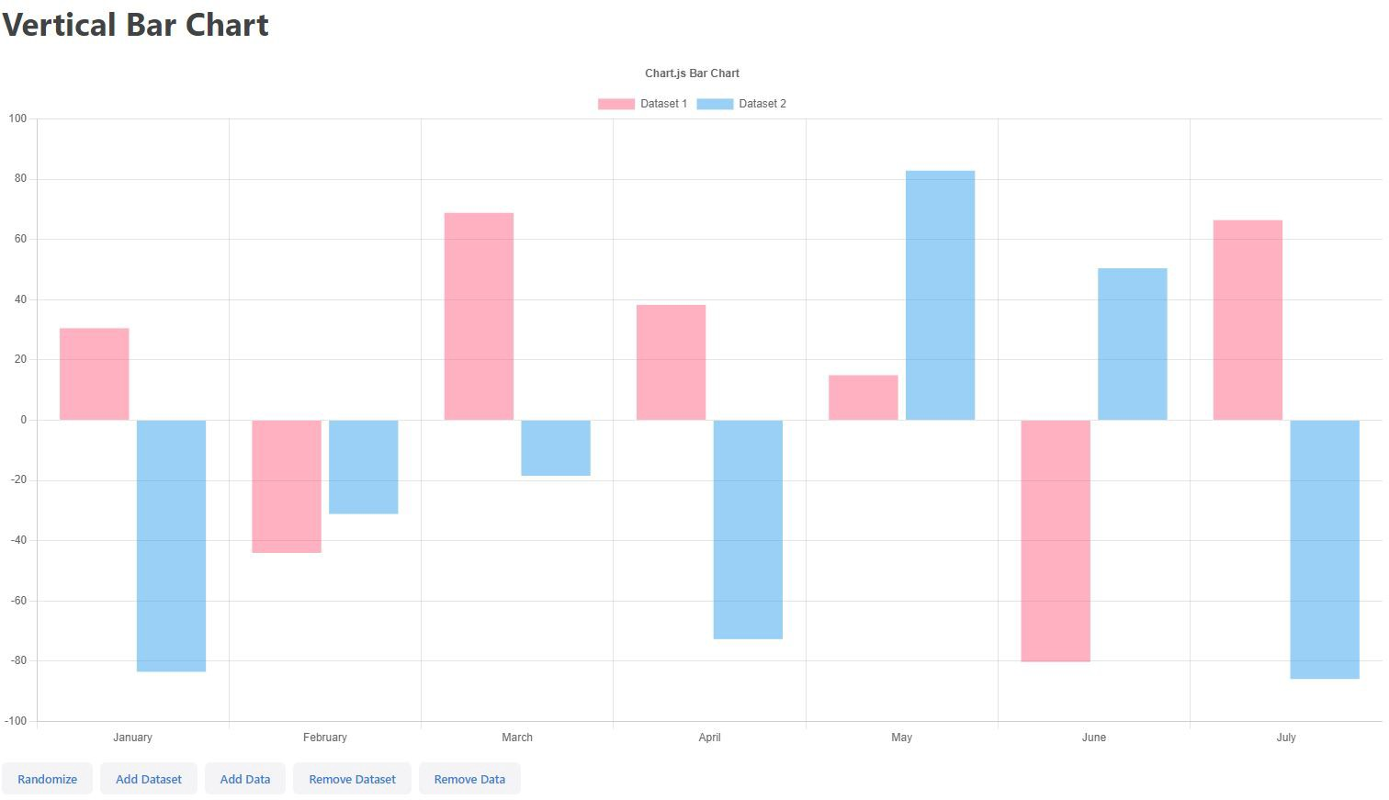Chart.js is a simple yet flexible JavaScript charting library for data visualization.

Its advanced features include:

* 8 chart types: bar, line, area, pie, bubble, radar, polar, and scatter
* Responsiveness
* Interactions
* Animations



Chart.js

**Getting Started**

First, include Chart.js in your page using a CDN. Then add an HTML canvas to your page. It is recommended to give the chart its own container for responsiveness.

Chart.js CDN:

<script src="https://cdn.jsdelivr.net/npm/chart.js"></script>

#### HTML:

<div>

<canvas id="myChart"></canvas> //your chart will display inside this canvas

</div>

Now we can create the chart. Insert the scripts below (in order) to configure the chart.

Define chart labels:

Set labels, colours and data:

Configure chart:



Chart.js

**Chart Settings**

const labels = [ 'January', 'February', 'March',

'April',

'May', 'June'

];

const data = { labels: labels, datasets: [{

label: 'My First Dataset', backgroundColor: 'rgb(255, 99, 132)',

borderColor: 'rgb(255, 99, 132)',

data: [5, 10, 5, 2, 20, 30],

}]

};

const config = { type: 'bar', data: data

};



Chart.js

**Display Chart**

Activity 5

Use exercise3.html in your Resources folder and try this yourself.

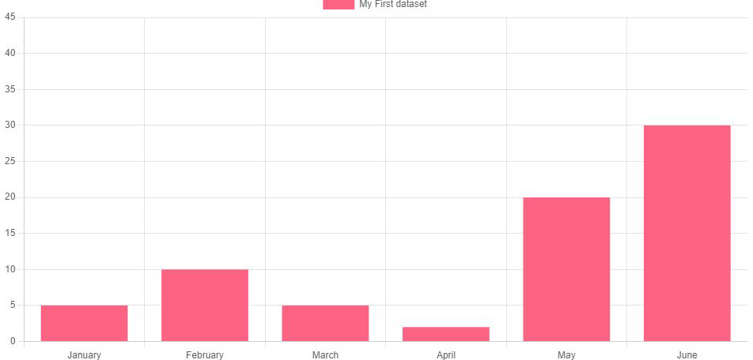Finally, render the chart based on your configuration.

Render chart in <canvas>:

const myChart = new Chart( document.getElementById('myChart'), config

);

Your chart should look like the image on the right.

Chart.js

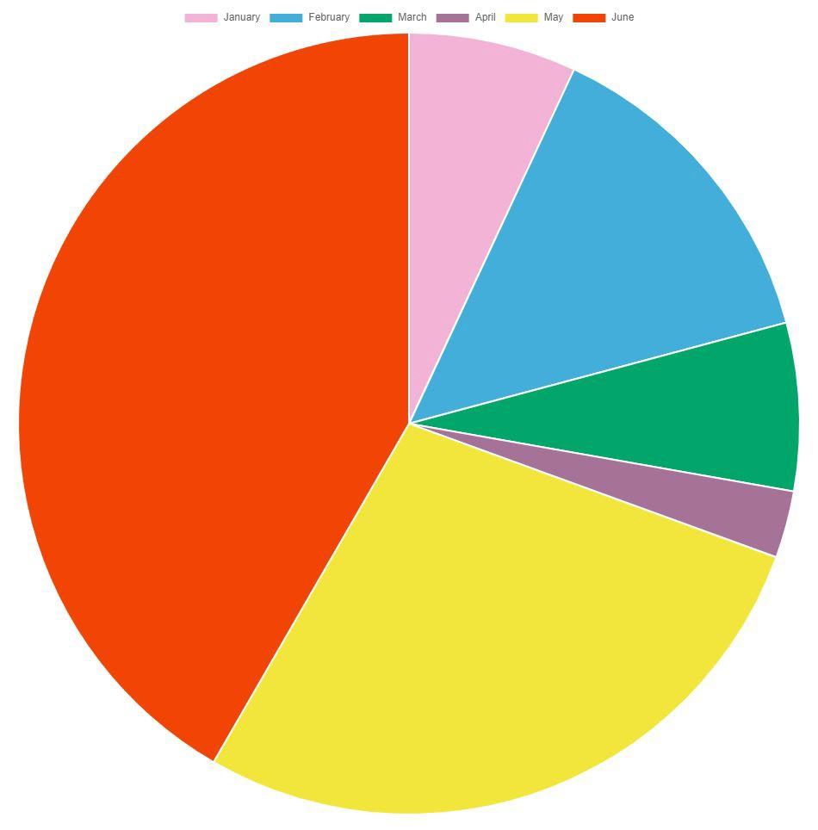

## **Pie Chart**

Now convert the bar chart that you have created into a pie chart.

Refer to this [documentation](https://www.chartjs.org/docs/latest/charts/doughnut.html#pie).

Your final result should look something like the image on the right.



Activity 6

Create a new HTML file named exercise4.html and configure and display a pie chart.



Chart.js

**Documentation**

View the [documentation](https://www.chartjs.org/docs/latest/) for Chart.js to learn more about it.

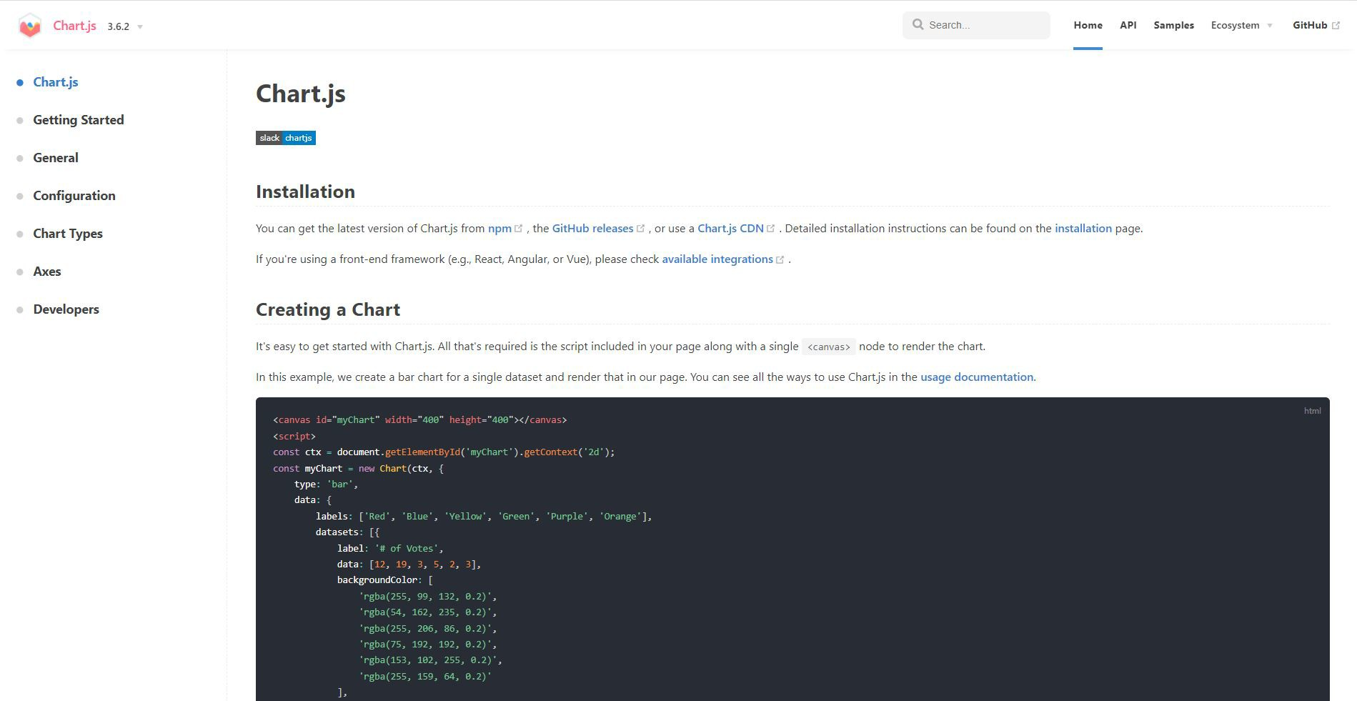



**Tippy.js**



[Tippy.js](https://atomiks.github.io/tippyjs/)

## **Tippy.js**



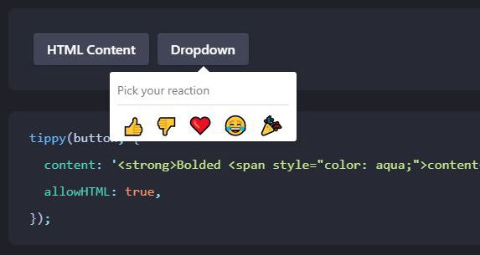Tippy.js is the complete tooltip, popover, dropdown, and menu solution for the web.

It provides the logic and optional styling of elements that pop out from the flow of the document and float next to a target element.

Features:

* Smart: will always float optimally in view
* Universal: compatible with mouse, keyboard, and touch inputs
* Customisable: fine-tunable functionality and fully stylable with CSS

Activity 7

Visit the [Demo](https://atomiks.github.io/tippyjs/) page to try out all the amazing features of Tippy.js.



Tippy.js

**Getting Started**

Tippy.js requires Popper to work. Hence, you need to include the CDN links for both Popper and Tippy.js.

#### CDN:

<script src[="https://unpkg.co](https://unpkg.com/%40popperjs/core%402)m/[@popperjs/core@2">](https://unpkg.com/%40popperjs/core%402)</script>

<script src[="https://unpkg.co](https://unpkg.com/tippy.js%406)m/[tippy.js@6"](https://unpkg.com/tippy.js%406)></script>

As usual, place them at the very bottom of the <body>, ensuring they are placed before your own scripts. The version numbers after @ are important - make sure they don't get removed.



Tippy.js

**Usage**

Activity 8

Create a new HTML file named exercise5.html and create a button with a tooltip.

Firstly, create an HTML element. In this example, we will be using a button. Then, simply call tippy() with the element’s CSS selector and a content property.

#### HTML:

<button id="myButton">My button</button>

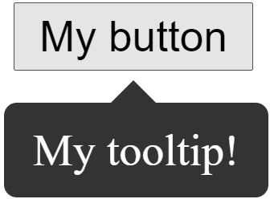JS:

tippy('#myButton', { content: 'My tooltip!',

});



Tippy.js

**Props**

Activity 9

Modify exercise5.html to include all these properties.

Props are configurable properties you can pass optionally to the tippy() constructor. Here are some common ones:

tippy('#myButton', {

placement: 'right', //place tippy to the right trigger: 'click', //trigger tippy on click

interactive: true, //allow interaction in tippy (e.g. click and select text) content: '<strong>Bolded <span style="color: aqua;">content</span></strong>', allowHTML: true, //allow HTML in tippy content

delay: 500, //delay tippy showing and hiding (in milliseconds) followCursor: true //get tippy to follow mouse cursor

});



Chart.js

**Documentation**

View the [documentation](https://atomiks.github.io/tippyjs/) for Tippy.js to learn more about it.

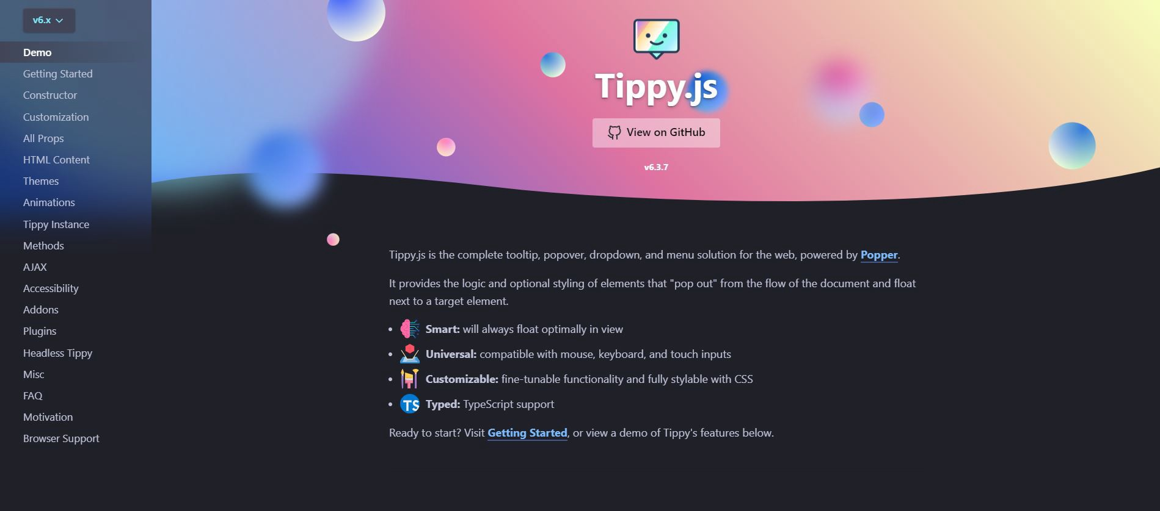



# **Quiz**

### Test your knowledge on DataTables, Chart.js and Tippy.js

#### START

You have unlimited attempts.

You are encouraged to score full marks before proceeding.

Quiz

Click the **Quiz** button to edit this object

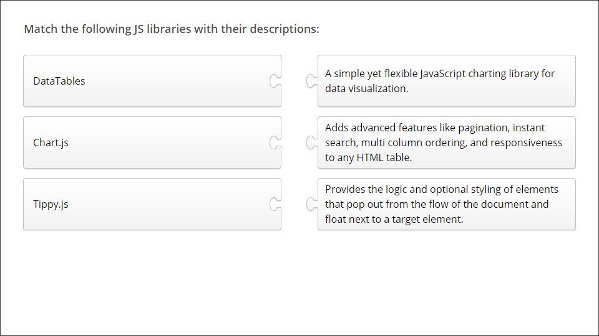

**L09 Assignment**

Using the three JavaScript libraries learned today, design a web page that displays information about polytechnics in Singapore.

Requirements:

1. Create hotspots on the Singapore map1 for the locations of the five polytechnics that shows a tooltip of the polytechnic name on hover
2. Display an interactive table containing diploma courses2 from RP
3. Insert a chart containing data on the number of students3 in each polytechnic All resources are provided in the L09 Assignment folder.
4. Use singapore.svg or singapore.png provided
5. Refer to courses.html for the data source
6. Refer to students.txt for the data



**Deliverables**

### Individual submission



Submit all deliverables by 2359 today

* + Exercises
    - Exercise 1
    - Exercise 2
    - Exercise 3
    - Exercise 4
    - Exercise 5
  + L09 Assignment

Zip the Exercises and L09 Assignment folders in one file for submission